**ЛИСТ СОГЛАСОВАНИЯ ВЫВОДОВ МИКРОКОНТРОЛЛЕРА**

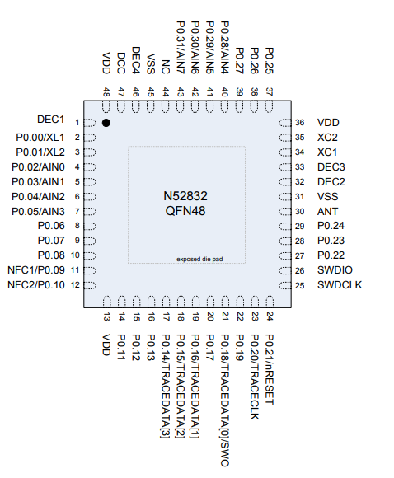

|  |  |  |  |
| --- | --- | --- | --- |
|  | CHRG (DIGIN) |  | LED1 |
|  | V_S_S (DIGOUT) |  | LED2 |
|  | V_S (AIN) |  |  |
|  | OUT_MCP(DIGOUT) |  | OSC32MHZ |
|  | MC_DIN(DIGIN) | Xc1 | 1 |
|  | OUT_1(AIN) | Xc2 | 2 |
|  | OUT_2(AIN) |  |  |
|  | OUT_3(AIN) |  | DLCK |
|  | OUT_4(AIN) |  | DIO |
|  | OUT_5(AIN) |  |  |
|  | OUT_6(AIN) |  |  |
|  |  |  |  |
|  | I2C |  |  |
|  | SLC |  |  |
|  | SDA |  |  |
|  |  |  |  |
|  | SPI |  |  |
|  | MOSI |  |  |
|  | SCK |  |  |
|  | NSS |  |  |
|  |  |  |  |

Проектирование электроники (ФИО, подпись, дата):__________________________________________________

Выводы согласованы с программистом (ФИО, подпись):_______________________________________________

Лист согласован с ведущим разработчиком (ФИО, подпись):____ Крестовников К. Д._____________ ____